Task 1: Science Inquiry – CNS Integration and Discrimination Validation Test

NAME ANSWER KEY Marks: /40
Time allowed: 45 minutes

A group of students conducted an investigation to test how task complexity affects discrimination time. They timed how long it took each individual to sort cards. Four different tasks were conducted, each increasing in complexity. The first task asked students to start with the pack face down, and turn each card face up, without further sorting. They then calculated the discrimination time required between the simplest task and the more difficult tasks.
Their results are shown in the table below.

Section 1 Investigation Design and Analysis of Data
[20 marks]

1: State a hypothesis for this investigation. (2 marks)

As task complexity increases (1), discrimination time increases (1)

(or similar, but students must clearly make a statement linking the IV and DV)

2: What was the independent variable? (1 mark)

Task Complexity (1)

3: State the dependent variable. (1 mark)

Discrimination Time (1)

4: Construct a line graph that plots the average discrimination time for males and females for
tasks B, C and D on the graph paper [round figures to the first decimal point]. (6 marks)

Results Table: Task time and discrimination time for male and female student as task complexity increases

Brain Investigation | Task time averages (s) |  |  |  | Discrimination time averages (s)
Student name | Task A | Task B | Task C | Task D | B-A | C-A | D-A
Female 1 | 24.9 | 32.8 | 44 | 68.6 | 7.9 | 19.1 | 43.7
Female 2 | 32.7 | 36.7 | 54.7 | 82 | 4 | 22 | 49.3
Female 3 | 31 | 39 | 53 | 82 | 8 | 22 | 51
Female 4 | 28.1 | 35.8 | 48.2 | 72.6 | 7.7 | 20.1 | 44.5
Female 5 | 26.7 | 32.7 | 43.3 | 77.3 | 6 | 16.6 | 50.6
Female 6 | 27.3 | 34.7 | 43 | 63 | 7.4 | 15.7 | 35.7
Female 7 | 31.3 | 36 | 52 | 91 | 4.7 | 20.7 | 59.7
Female 8 | 30.3 | 40 | 51 | 79 | 9.7 | 20.7 | 48.7
Female 9 | 32.7 | 39.7 | 53.3 | 72 | 7 | 20.6 | 39.3
Female 10 | 22 | 29.3 | 40.3 | 60 | 7.3 | 18.3 | 38
Female 11 | 24.3 | 36.7 | 49.3 | 85 | 12.4 | 25 | 60.7
Female class averages * | 28.3 | 35.7636 | 48.3727 | 75.6818 | 7.46364 | 20.0727 | 47.3818
Male 1 | 29.3 | 46 | 60 | 99 | 16.7 | 30.7 | 69.7
Male 2 | 35.3 | 40.3 | 69 | 84 | 5 | 33.7 | 48.7
Male 3 | 30 | 39 | 50 | 65.5 | 9 | 20 | 35.5
Male 4 | 21.3 | 30.7 | 39 | 64.7 | 9.4 | 17.7 | 43.4
Male 5 | 19.3 | 33.7 | 39.7 | 69.3 | 14.4 | 20.4 | 50
Male 6 | 25 | 38.3 | 43 | 59.6 | 13.3 | 18 | 34.6
Male 7 | 20.3 | 31.3 | 41.3 | 57 | 11 | 21 | 36.7
Male 8 | 18.3 | 31 | 37.6 | 47.6 | 12.7 | 19.3 | 29.3
Male class averages * | 24.85 | 36.2875 | 47.45 | 68.3375 | 11.4375 | 22.6 | 43.4875
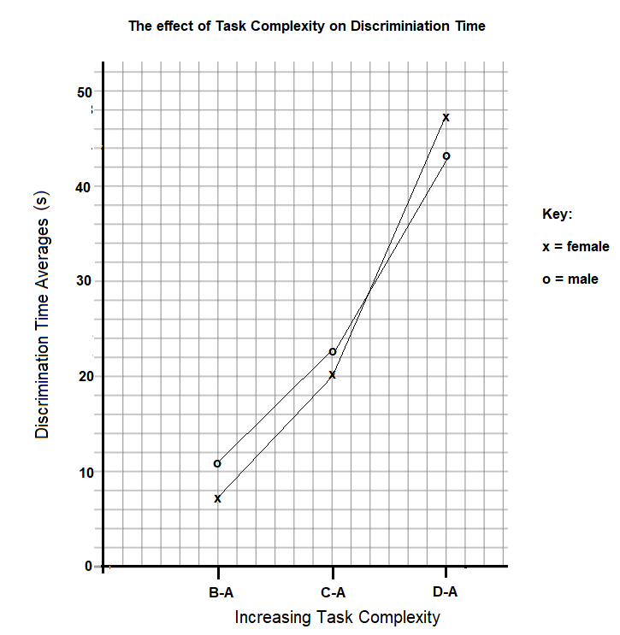

Graph Marking Key:

Title (must include independent and dependent variables, may also include “by gender”) (1)

X axis labelled correctly including identification of tasks (1)

Y axis labelled correctly (0.5) with units (0.5)

Consistent increments for time on Y axis (1)

Key showing genders, and two lines plotted (1)

Points plotted accurately (1)

5: Use the table and your graph to answer the following questions:

- Which gender showed the shortest discrimination time for task D? (1 mark)

Females (1)

- Which gender showed the longest discrimination time for task B? (1 mark)

Males (1)

6: Identify the control for this investigation and outline why this is used as the control. (2 marks)

The control for this investigation is Task A (1). It requires very little discrimination, so it can be used to compare how much discrimination time is used for other tasks. (1) must talk about the comparison and what is compared to get full marks.

7: List four other controlled variables. (4 marks)

Any 4 reasonable variables for one mark each. May include:
Same number of cards in deck each time
Same type of playing cards
Same order of trials completed
Same shuffling technique
Same shuffling duration
Same method for turning over cards to expose face.
Same age of participants
Method of timing.

Do not accept “the environment” or other vague variables. Do not accept just “the cards”. They need to be specific.

8: Identify the main trend in the data between discrimination time and tasks performed. (2 marks)

As task complexity increases (1), discrimination time increases.(1)

Must link complexity and discrimination time.

Section 2: Communicating findings using understandings of Human Biology
[20 marks]

1: Which part of the cerebrum processes and decides on the sequence of actions that need to
be performed in correctly sorting out the cards? (1 mark)

The Frontal Association Area

2: Which part of the cerebrum integrates and sequences the movements required? (1 mark)

The Motor Association Area

3:
Explain why task D took longer than task B. (2 marks)

More decisions needed to be made in deciding where to place the cards (1)
Therefore longer/more complex neuron pathways engaged (1)

4: What type of matter in the cerebrum enables saltatory conduction to occur? (1 mark)

White Matter / Myelinated axons (1 mark for either)

5: Explain how this brain matter allows saltatory conduction to occur. (4 marks)

Myelin sheath blocks ion channels (1) except at Nodes of Ranvier (1). Sodium ions can therefore diffuse quickly from node to node (1), increasing the speed of transmission (1)

6: John is unable to perform the card playing activity because of muscle tremors. Identify the area of the brain that would cause this problem for John and describe the role it plays in normal functioning.
(3 marks)
The cerebellum (1) has caused the issue.
The role it plays in normal functioning is to smooth movement (1) and maintain muscle tone and posture(1)

7: The motor neurons that innervate the muscles of the arms and fingers receive messages from the connector neurons in the brain, which have in turn received messages from sensory neurons. This enables the fingers to clasp and turn over the card to the correct pile.

Explain how the electrical impulse of a sensory neuron is propagated and travels along the sensory neuron to enable this to happen. (8 marks)

Membrane of sensory neuron is stimulated (1)
This causes gated ion channels to open (1)
Some sodium ions move in, changing the membrane potential (1)
As the stimulus goes beyond the threshold of -55mV (1) must have -55mV for the mark
More sodium ions flood inwards across the membrane (1)
And complete depolarisation occurs. (1)
Depolarisation in one section of membrane triggers depolarisation in the next (1)
So the impulse is transmitted along the length of the sensory neuron. (1)

Do not accept description of saltatory conduction as sensory neurons are unmyelinated.

